SILENT RUNNING
Fuel Delivery Without The Buzz

Electric fuel pumps have been gaining in popularity since the 1960’s when drag racers found that adding an electric fuel pump near the fuel tank helped prevent the dreaded “nose-over” during hard acceleration. Often, an improvement was found even when these pumps were added to an otherwise stock fuel system still using the OEM fuel lines and engine mounted mechanical fuel pump.
The electric pumps of the era weren’t able to provide the huge volume associated with many of today’s monster pumps. Still, they improved matters even if they didn’t flow anymore than the mechanical pump they were feeding because they prevented a vacuum from forming in the fuel line. As with most fluids, gasoline is much more likely to boil or vaporize if it is subjected to a vacuum. Once the fuel vaporizes, it is very difficult for any type of pump to deliver the fuel efficiently.
Eventually, aftermarket companies began to supply electric pumps that could supply so much volume that the stock mechanical pumps became a restriction and were removed altogether. A few high volume mechanical pumps were developed (most commonly for Chevy and Ford circle track engines where the rules often dictate a mechanical pump) but the vast majority of drag race cars today use electric pumps whenever the rules allow it.
Unfortunately, electric fuel pumps have some of their own problems, especially when used on street/strip cars. Electric pumps are generally noisier, more expensive, shorter lived and more sensitive to debris than similar flowing mechanical pumps. Electric pumps must be mounted as low and as close to the fuel tank as possible. On street driven cars, finding a convenient place to mount an electric pump can be difficult, and the noise created by many electric pumps can be annoying. Electric pumps also require electrical wiring including a relay for some of the bigger pumps.
In contrast, high performance mechanical pumps are quiet, require no electricity and mount in place of the stock pump on the engine. But can a mechanical pump really provide enough fuel for a high performance engine during high g-force acceleration? And if you happen to drive or race something other than a SB/BB Chevy or Ford, can you even find a true high volume mechanical fuel pump?
We decided to test a RobbMc Performance Products high volume mechanical pump on a street/strip AMX. RobbMc manufactures high volume pumps (in two versions) for AMC, Buick, Cadillac, Olds, Pontiac, Ford FE, Ford Cleveland, and Chevy V8 engines. The smaller pumps (550HP series) have a free flow of about 130 gph and do not require a pressure regulator. The larger pumps (1100HP series) have a free flow of about 180 gph and require a regulator.
Our 1980 Spirit AMX has a recently installed 401 cid engine which produces about 400 horsepower; enough to propel the lightweight into the 12’s on street legal tires and possibly the 11’s with some slicks, proper gearing and chassis work. We installed an Autometer electric fuel pressure gauge in the dash so we could monitor the fuel pressure during full throttle acceleration.
Our goal was have a fuel system that maintained at least 4.5 psi at all times. First we tested the original, stock fuel system with no changes. The stock pump produced 5 psi at steady speed. Since the stock system was designed for an engine producing well under 200 horsepower, we weren’t surprised when the fuel pressure dropped below 0.25 psi under full throttle. The engine fell flat and only recovered after I partially lifted my foot from the gas pedal.
We next tried blocking the bleed (sometimes called “vapor return”) line. Many carbureted cars came from the factory with a ¼” bleed line which allows a small amount of fuel to circulate back to the tank. This keeps the fuel cooler and helps prevent fuel vaporization. Blocking the bleed line provides a slight increase in volume and pressure. The pressure at steady speed was now 6 psi and dropped to about 1 psi under full throttle; a small improvement. However, the improvement was short lived. As the engine began to heat soak, the fuel pressure became erratic and eventually dropped below 0.25 psi during full throttle. Blocking the bleed line only worked while the engine was relatively cool. (However, placing a valve in the bleed line might work since the valve could be left open until just before making a pass.)
Next we installed the RobbMc 550HP series fuel pump (with the vapor return option so we could connect the factory bleed line). We left everything else stock, including the 5/16” fuel line. Fuel pressure at steady speed was 6 psi. At full throttle, the fuel pressure dropped to 1-1/2 psi. An improvement over the stock pump, but not what we were hoping for from a pump that should produce nearly three times as much volume. We then blocked the bleed line. At steady speed the pressure was now 6.5 psi and only dropped to 3 psi at full throttle. But once again the pressure became erratic as the engine warmed up, especially when we were caught in traffic and not moving very fast.
The instructions included with the RobbMc pump recommend a 3/8” or larger fuel line (1/2” or larger if the engine produces over 450 horsepower) from the tank to the pump. We decided to replace the factory 5/16” line with 1/2” rather than 3/8”since we only wanted to do the job once and we might be increasing the engine output at a later date. RobbMc also manufactures ½” sending units for stock gas tanks for many muscle cars but unfortunately not for AMC Spirits. So we reused the factory 5/16” sending unit even though we were now using ½” fuel line. We did however, remove the factory “sock” filter from the sending unit and replace it with a RobbMc 100 micron inline pre-filter. We were rewarded with a fuel pressure that now only dropped to 3.5 psi at full throttle, even with the bleed line in use. The car now pulled hard in every gear, all the way to redline. However, we still hadn’t reached our goal of a fuel pressure of at least 4.5 psi during full throttle acceleration.
We removed the stock sending unit for a second time. It looked pretty restrictive so we fabricated a ½” pickup tube and reinstalled. We made another full throttle pass and the fuel pressure never dropped below 4.5 psi. We’d reached our initial goal but wondered if we could make any further improvements.
We had originally installed the RobbMc pump without the optional bottom outlet plate as this option costs another $30. However, we had to use a very sharp, 90 degree fitting on the outlet port in order to clear the radiator hose. While reducing restriction on the inlet side is more important than on the outlet (because the inlet is under a vacuum), the 90 degree outlet fitting appeared very restrictive so we decided to install the bottom outlet plate and a larger outlet hose. We also replaced the factory style filter at the engine with a RobbMc 40 micron post-filter.
We made another full throttle pass and the fuel pressure never dropped below 5 psi the entire ¼ mile! We now only had a 1 psi pressure drop and we were even using the bleed line. Smiles all around!
A pressure drop of only 1 psi is very good for any type of fuel system where a regulator is not required. The system would certainly be adequate for our AMX. Still, now that we’d had so much success with a low pressure mechanical pump, we wondered what the results would be with a high pressure mechanical pump and a regulator.
Whenever a low pressure pump is used, there will always be at least some amount of fuel pressure drop to the carburetor during full throttle acceleration. This is true for electric pumps as well as mechanical. Pumps produce the most pressure at zero flow and produce the most flow at zero pressure (called “free flow”). So, as the engine demands more fuel, pressure is traded for volume. This is why high pressure pumps and pressure regulators are used in systems for serious race cars. While the fuel pressure being produced by the pump still drops during full throttle, as long as the pressure produced doesn’t fall below the set pressure of the regulator, the pressure delivered to the carburetor changes very little.
We installed a RobbMc 1100HP series pump and dead-head regulator on our AMX, just to see the results. While we certainly didn’t need the added volume, we wanted to see how much pressure drop would occur at full throttle with a high pressure pump and regulator. The maximum pressure delivered by the 1100HP pumps is adjustable. We adjusted the pump pressure to 10 psi and then adjusted the regulator to 6 psi to avoid flooding the carburetor. Full throttle acceleration tests revealed a system which now held a steady 6 psi from launch to the end of the ¼ mile.
By using large fuel lines with a high performance mechanical pump, it really is possible to have your fuel and not hear it too.

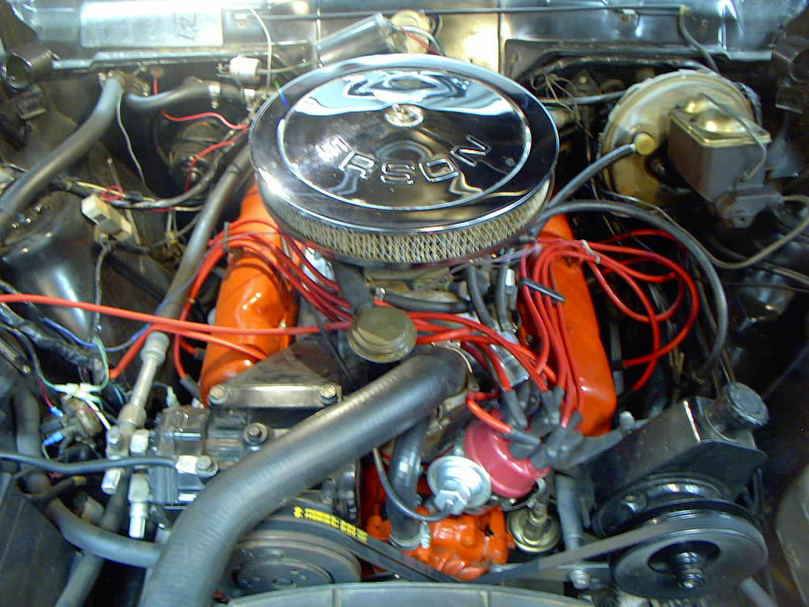

Our AMC 401 uses 10 to 1 compression and products from Erson, Mallory, Edelbrock, Hedman and Holley to produce around 400 horsepower. The stock type fuel pump is visible below the distributor. It severely limited performance.

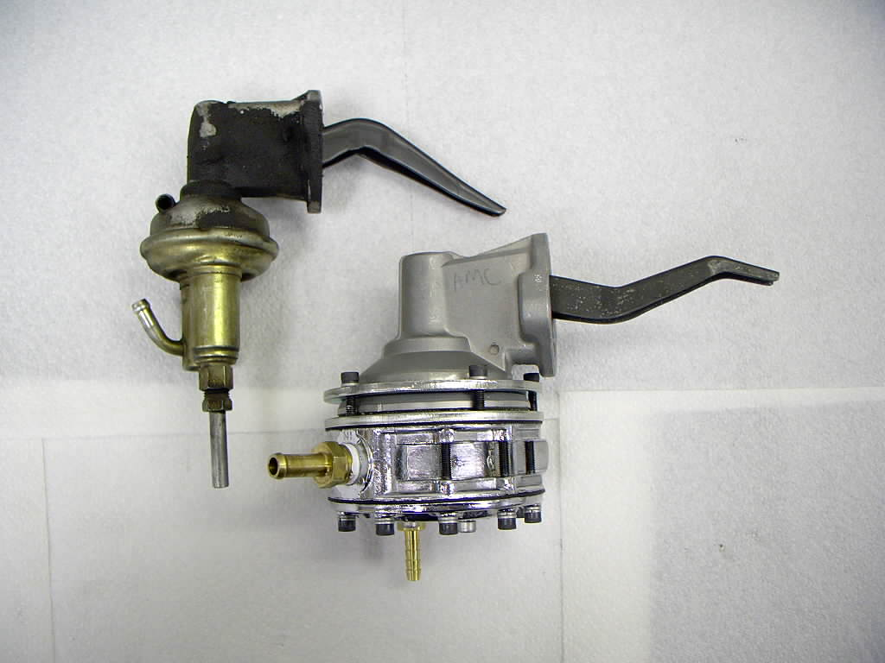

The stock pump next to the RobbMc 550HP series. The valve body portion of the RobbMc pump can be rotated to any position by loosening the five screws in the upper clamp ring. The bottom fitting on the RobbMc pump is the optional “vapor return” outlet which connects to the factory bleed line. (This bleed line is connected to the fuel filter when running the stock pump.) Running either pump without the bleed line helps performance; but only until the engine reaches full operating temperature.

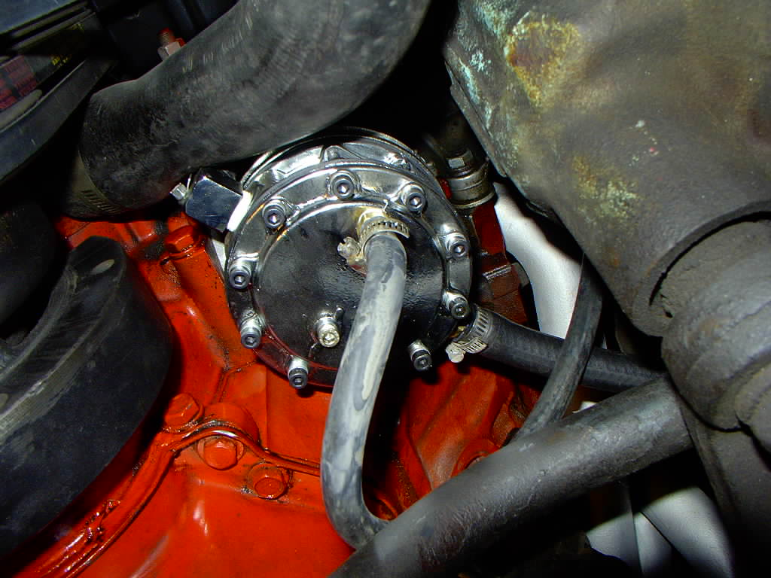

The 5/16” factory fuel line is connected to the pump with a straight barb fitting. The ¼” hose coming off the bottom is the factory vapor return/bleed line. We originally used a chrome 90 degree fitting on the outlet to clear the radiator hose.

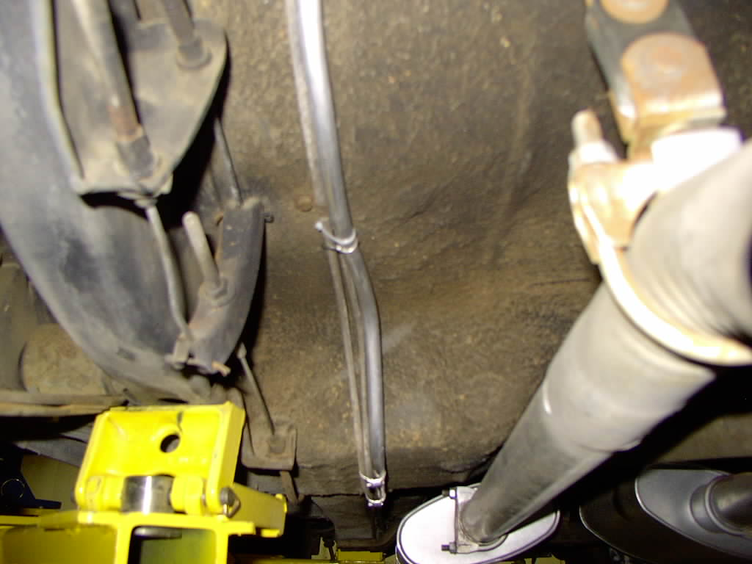

We replaced the factory 5/16” feed line with ½” aluminum and routed it along the same path as the original line. The other two smaller lines are the bleed line and the gas tank vent line which runs up to a charcoal canister in the engine compartment.

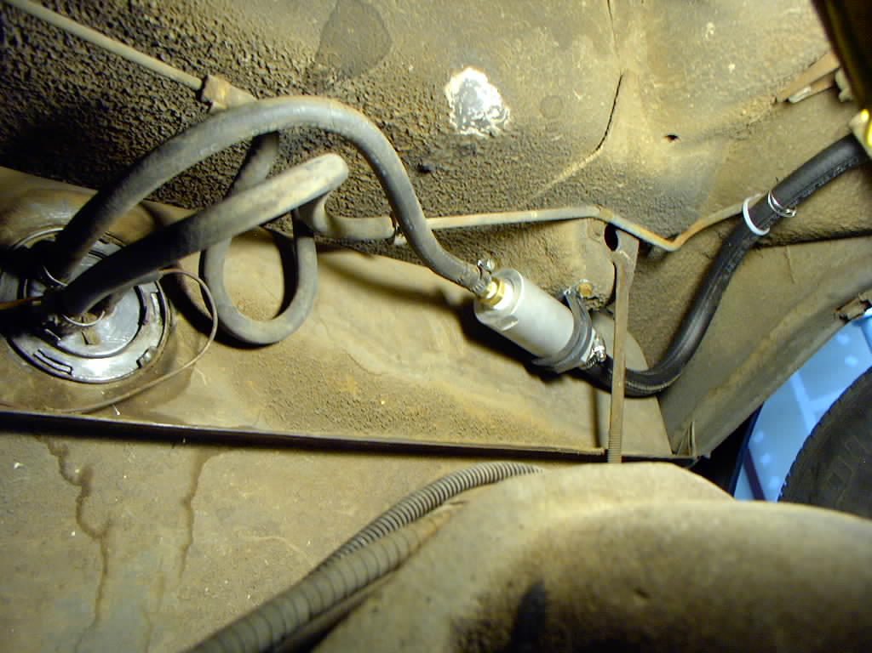

RobbMc doesn’t sell a ½” sending unit for our AMX, so we first tried using the stock 5/16” unit after replacing the “sock” filter in the tank with a RobbMc inline pre-filter. The filter also gave us a convenient place to reduce the new ½” line down to 5/16”.

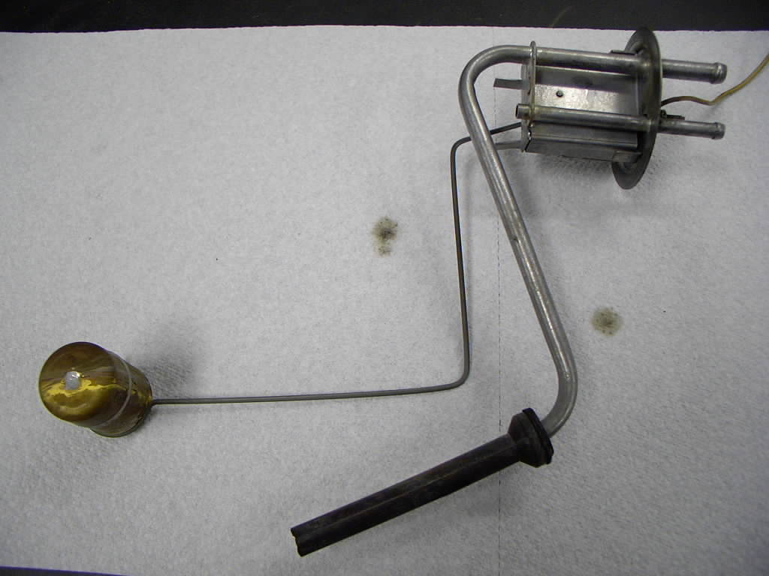

The factory 5/16” pickup tube is small to begin with. The sharp bend near the top nearly kinks the tube in half. The “sock” filter has already been removed.

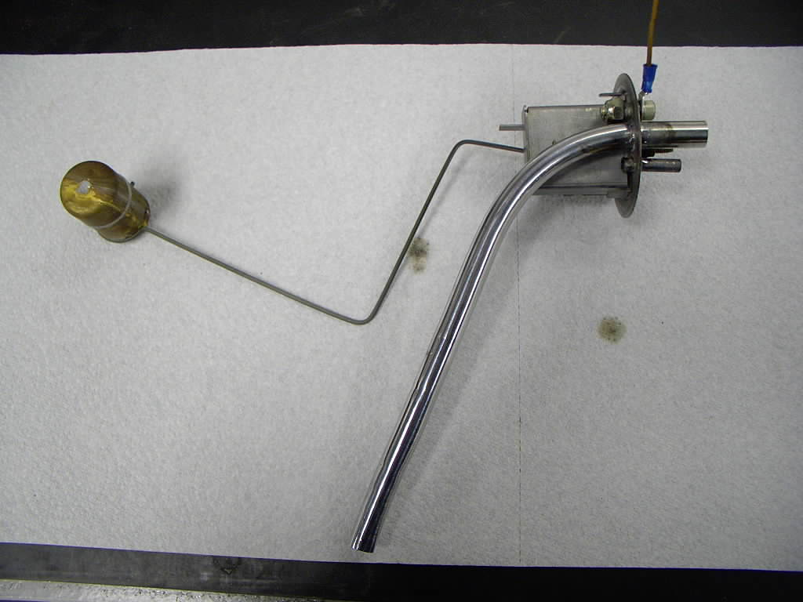

It took some time, but we were able to replace the 5/16” pickup tube with a fabricated ½” tube. The bottom of the tube is at the same location as the original. Care must be taken to make sure the assembly will still fit through the hole in the tank. The fuel system responded favorably to the change.

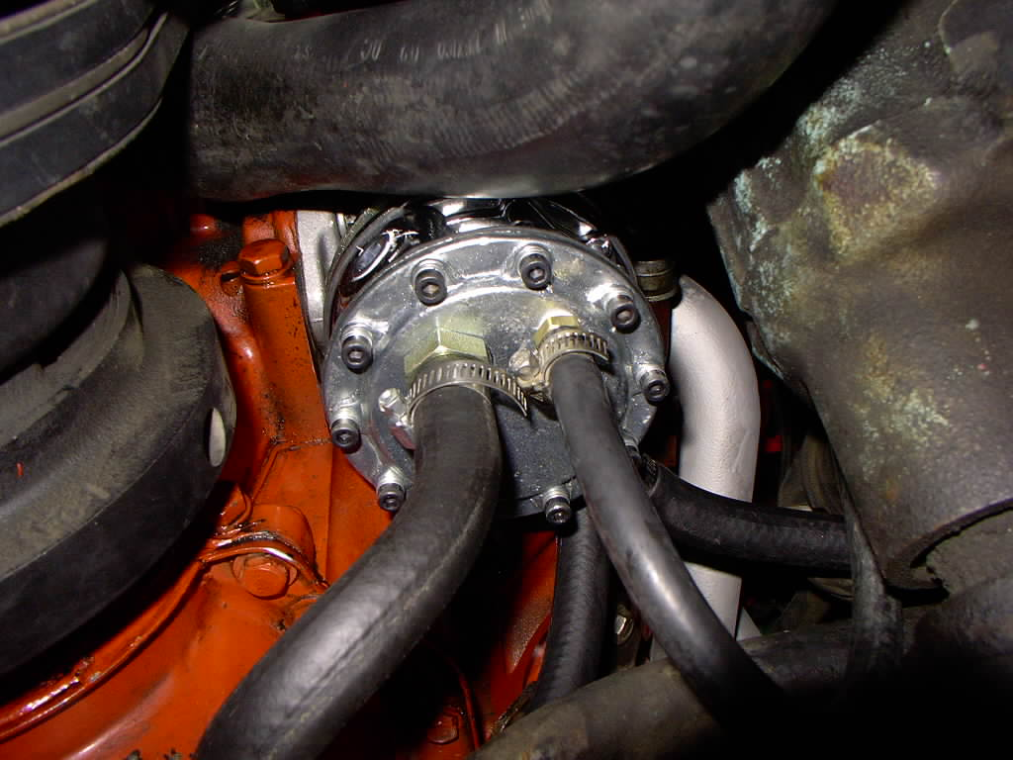

Our final change was to replace the sharp 90 degree 3/8” outlet fitting with a straight ½” fitting using the RobbMc bottom outlet option. We looped a ½” rubber line up to the filter. This much rubber line would be frowned at by most drag strips but it allowed us to cheaply test the effect of reducing the restriction on the outlet side of the pump. With all the changes in effect, the fuel system only dropped 1 psi under full throttle acceleration compared to the factory system which dropped nearly 5 psi.

