
RobbMc Performance Products
2960 Cameron Court
Carson City, NV 89706
(775) 885-7411
robb@robbmcperformance.com
www.robbmcperformance.com

INSTALLATION INSTRUCTIONS FOR

ROBBMC MINI STARTER

PART NOS. 2000, 2001, 2002, 2003, 2004, 2005, 2006, 2007

GENERAL INFORMATION
Because RobbMc's Mini Starter is smaller than stock, and the solenoid can be rotated to any position, installation is usually easier than installing a stock starter. However, there are a few things that should be checked to prevent damage to the starter and/or flywheel.

INSTALLATION

Step 1
Disconnect the negative battery cable from the battery. Remove the stock starter.

Step 2
Loosen the V-clamp on the starter just enough to rotate the starter by hand.

Step 3
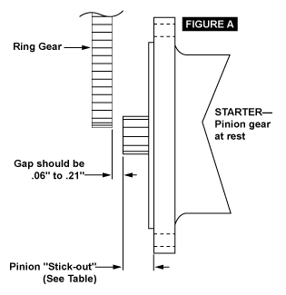
Hold the starter in place (do not bolt-up yet) and determine the best position for the solenoid by rotating the starter relative to the nose. Try to leave a minimum 1/2" air gap between the exhaust and the solenoid. Remove the starter and tighten the v-clamp to lock the solenoid in position.

Step 4
Determine the gap between the starter pinion gear and the flywheel ring gear. NOTE: In most cases, this step is not necessary. However, it is highly recommended to prevent damage to the starter. With the pinion gear at rest, there should be .06" to .21" between the pinion gear and the ring gear. In some cases, it is not possible to visually check the gap, so it must be calculated.

BELLHOUSING MOUNT STARTERS
If you cannot see the gap when the starter is installed, measure the distance from the starter-mounting surface to the ring gear and compare that with the distance the pinion sticks out of the starter. There should be .06" to .21" difference. See Figure A.
Mini Starter Installation Page 2

Pinion "stick-out" of RobbMc bellhousing mount starters:
Part No. 2002 Ford BB Starter .50"
Part No. 2003 Ford "manual trans" starter .25"
Part No. 2001 Ford "auto trans" starter .62"
Part No. 2005 Mopar starter .94"
Part No. 2006 AMC starter .70"
Part No. 2007 Hemi 4-speed starter 1.19"
If the pinion is too close to the ring gear, the pinion gear can be replaced with a RobbMc "short" gear (PN 2009*), which moves the pinion back .125".

* NOTE: Gear PN 2009 will not fit Mopar Starter PN 2005.
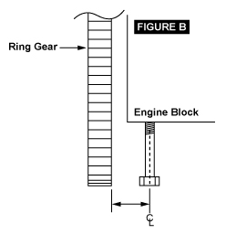

BLOCK MOUNT STARTERS
If you cannot see the gap with the starter in place, remove the starter and screw a starter bolt into the block. Measure from the center of the bolt to the ring gear. Compare this measurement with the distance that the pinion gear sticks out past the bolt holes on the starter. See Figure B.

Pinion "stick-out" (past bolt holes) of RobbMc starters:
Part No. 2000 Chevy/Buick starter .87"
Part No. 2004 Pontiac/Oldsmobile starter .87"
The difference should be .06" to .21".

If the gear is too close, use RobbMc Gear PN 2009 to increase the clearance by .125".

Step 5
Bolt the starter in place with the solenoid in the desired position. RobbMc Starters are designed to use the stock type and length starter bolts. If you do not have the correct bolts, they are available at any auto parts store.

NOTE: GM block mount starter bolts have a knurl on the shank near the threads. Do not use bolts without the knurl.
Mini Starter Installation Page 3

Step 6 (Wiring)
Vehicles without remote solenoid/relay, including most GM/Mopar:

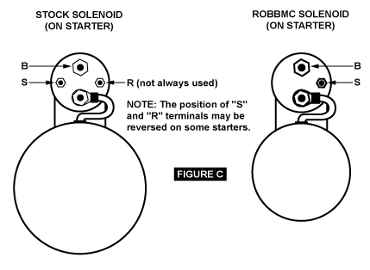

"B" Terminal
Remove all wires from the large B terminal (including the battery cable) on the stock solenoid. Connect all wires to the same terminal on the RobbMc solenoid.

"S" Terminal
This is the small terminal that is connected to the starter switch/key. The wire(s) connected here activate the starter. Remove the wire(s) from the stock solenoid and connect them to the small terminal on the RobbMc solenoid.

NOTE: This terminal may be on the opposite side of the solenoid compared to the stock starter.

"R" Terminal
Some older cars have one or more wires connected to a second small R terminal. These wires are not used on a RobbMc starter.

Mini Starter Installation Page 4
(Wiring) Continued:

Vehicles with remote Solenoid (includes most Ford/AMC):

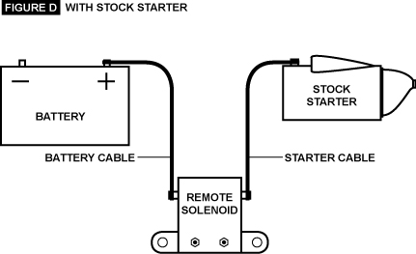

Move the starter cable from the current position on the remote solenoid to the opposite side (same side as battery cable).

Run a 10 gauge or larger wire from the remote solenoid terminal (where the starter cable used to be) to the small terminal on the RobbMc starter solenoid.

NOTE: RobbMc does not recommend using a jumper wire on the solenoid. Installing a jumper wire on a permanent magnet motor can result in current feedback, which can cause the pinion to remain engaged with the flywheel after the engine starts. This will result in eventual starter failure.

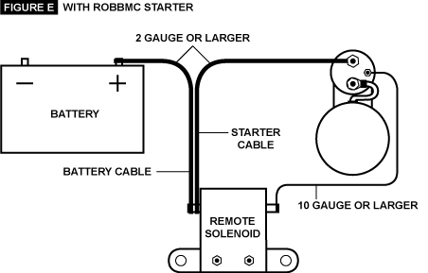
Step 7 (Starter Shims)
When using a starter that bolts to the engine block, it is sometimes necessary to shim the starter to get smooth engagement. If the starter grinds (does not engage ring gear smoothly) when the key is turned, shims may be required. RobbMc Starters are designed to use the stock type shims available at any auto parts store. Start with the thinnest shim. Do not use any more shims than necessary to get smooth engagement. No more than .093" of total shims should ever be used. If the starter still does not engage smoothly, check the ring gear teeth for damage.

NOTE: If the starter engages the ring gear but is noisy while turning the engine over, too many shims are being used or the ring gear/pinion gear is damaged.
RobbMc Performance Products
2960 Cameron Court
Carson City, NV 89706
(775) 885-7411
robb@robbmcperformance.com
www.robbmcperformance.com
© 2006 ROBBMC PERFORMANCE PRODUCTS. ALL RIGHTS RESERVED

