
OVERSIZE FUEL TANK SENDING UNIT/PICKUP ASSEMBLY

Part Number: 1079 Sending Unit Specifications: 0-90 ohm
Applications: 1974-1981 GM "F-body" cars including Camaro, Firebird and Trans Am
1973-1979 Nova/Skylark/Omega/Phoenix/Ventura
General Info: This sending unit assembly features oversize ½” tubes for high horsepower applications. The ½” return tube is ideal when using a return style regulator. The sending unit works with stock fuel level gauges. Compatible with gasoline or alcohol fuels.
Pickup Tube Size: ½” Feed and Return Tube: ½” barb (or -8AN/-10AN with option PN 1070/1080)
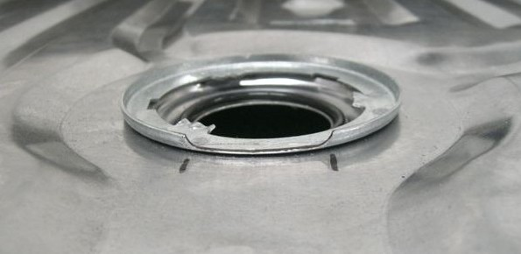
Installation: Installation is very similar to installing a stock type sending unit (see repair manual).
NOTE: Some aftermarket tanks require modification to the lip to clear the ½” tubes. (See photo to the right).

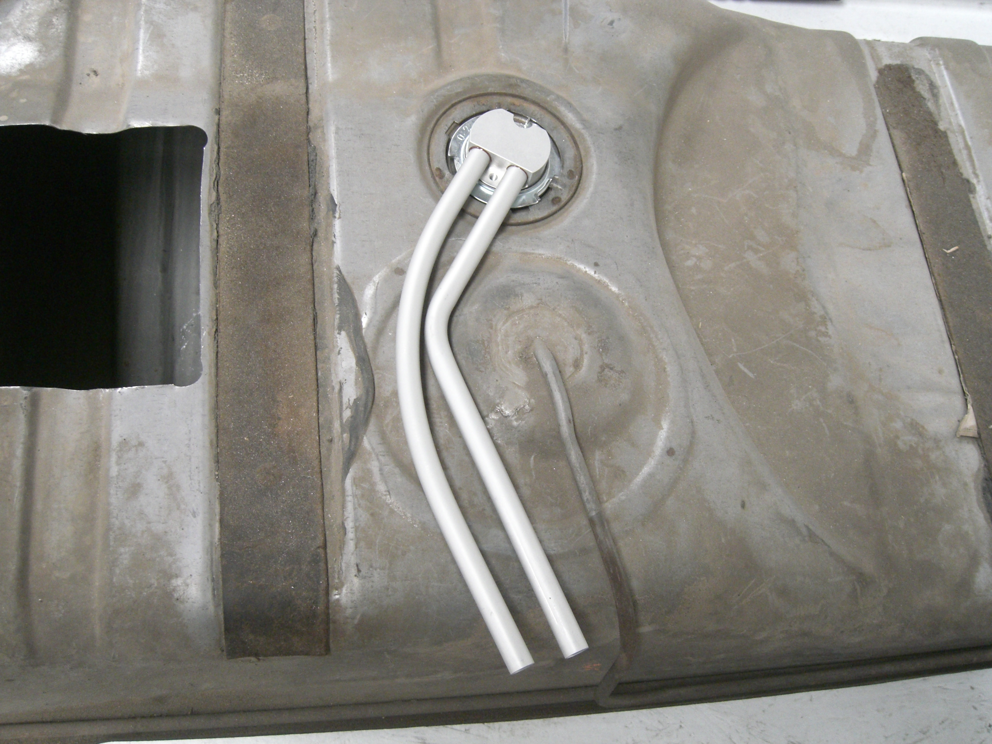
O-Ring: The RobbMc assembly uses an off-the-shelf #226 o-ring (included) to seal to the tank. While not the same as the stock o-ring, replacement o-rings are available at most hardware and auto parts stores.
MODIFICATION TO CLEAR TUBES
Wiring: The black wire must be connected to ground in the same manner as the factory sending unit. The red wire must be connected to the wire which runs up to the fuel level gauge. The wire terminal on the factory fuel gauge wire will not connect to the RobbMc sending unit. The terminal must be removed and the factory wire connected to the red wire on the sending unit with a butt connector or male/female blade connectors.
Filter: This RobbMc assembly is designed to be used without the factory style in-tank “sock” filter as these filters become restrictive over time and are difficult to service. Use an external inline prefilter such as RobbMc PN 1025 or 1029.
Return Line: The return tube is ½” to allow the use of a ½” or -8AN/-10AN return line from a return style regulator. If using a mechanical pump with a ¼” “vapor” return line, connect a short section of ½” rubber line to the tube and then reduce it to ¼” with a reducer fitting (available from RobbMc as PN 1071). If no return line is used, cap off the return tube.
Notes:
~ When racing, try to keep the gas tank at least half full to keep the fuel from sloshing away from the pickup tube and sucking air into the tube.
~ The float on the RobbMc unit may point in the opposite direction from the stock sending unit.
~ Due to variations in tanks and sending units, the fuel level gauge may read slightly higher or lower than with the stock sending unit.
~When connecting braided AN lines to the tubes, be sure to hold the RobbMc fitting with one wrench while tightening the AN line with another wrench to avoid damage to the aluminum tube.
~If the gauge doesn’t work after installation, make sure the black wire has a good ground and make sure the ring connector on the red wire is not shorting against the clamp ring on the sending unit.

