
RobbMc Performance Products
1717 La Mirada Street
Carson City, NV 89703
(775) 885-7411
robb@robbmcperformance.com
www.robbmcperformance.com

ROBBMC GEN II MINI STARTER

WARNING: DO NOT USE A “JUMPER WIRE” ON THE SOLENOID. SEE THE WIRING INSTRUCTIONS

NOTE: RobbMc Starters are designed to use the stock, OEM type and length starter mounting bolts. If you do not have the correct bolts, they are available at any auto parts store. GM block mount starter bolts must have a knurl on the shank near the threads.

Step 1: REMOVE THE STOCK STARTER
Disconnect the negative battery cable from the battery. Remove the existing starter.

Step 2: FIND THE BEST POSITION FOR THE ROBBMC SOLENOID
The solenoid can be rotated to any position, without removing any bolts. Use a 5/16” wrench or socket to loosen the two hex head adjuster bolts on the end of the RobbMc starter motor (See Photo 1). This allows the solenoid to be rotated relative to the nose. (*See note below).
Bolt the starter in place on the engine/transmission and rotate the solenoid to the best position for your application. There must be a ½” minimum air gap between the exhaust and the solenoid.
Use a 5/16” socket to tighten the two adjuster bolts (45 in-lbs) and lock the solenoid in position.

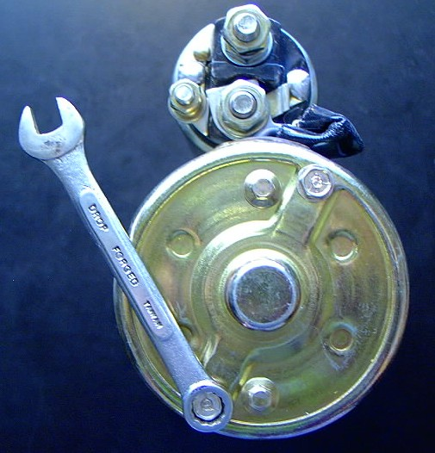
PHOTO 1
USING A 5/16” WRENCH TO LOOSEN THE ADJUSTER BOLTS SO THE SOLENOID CAN BE ROTATED TO A DIFFERENT POSITION

*NOTE: The solenoid may be difficult to rotate, even with the adjuster bolts loose. If so, make sure both adjuster bolts have been loosened two to three full turns (but do not remove the bolts) and then tap on the heads of the adjuster bolts with a small hammer. This will release the locking mechanism and make it easier to rotate the solenoid.

Step 3: CHECK THE END GAP BETWEEN THE PINION GEAR AND RING GEAR
When the pinion gear is retracted, there should be a .062" to .187" (1/16” to 3/16”) gap between the pinion gear and the ring gear. (See Figures A and B on page 2)

CHECKING THE END GAP WITH STARTERS THAT MOUNT TO THE TRANSMISSION OR BELLHOUSING (See Figure A on page 2): If you cannot measure the gap with the starter installed, remove the starter and measure the distance from the starter-mounting surface to the ring gear and subtract this measurement from the pinion “stick-out” of the starter (See Table 1 on page 2). The difference should be .062" to .187" (1/16 to 3/16).

Table 1: Pinion "stick-out" of RobbMc bellhousing/transmission mount starters:
PN 3001 Ford: 0.62" PN 3002 Ford: 0.50" PN 3008 Ford: 0.25” PN 3026 Ford: 0.62”
PN 3005 Mopar: 0.94" PN 3007 Hemi: 1.31" PN 3006 AMC: 0.66" PN 3029 Olds: 0.88"
PN 3031 Ford: 0.62"

If the pinion is too close to the ring gear, install the provided 1/16 (.062”) thick round shim (See Page 3).

CHECKING THE END GAP WITH GM STARTERS THAT MOUNT TO THE ENGINE BLOCK
(See Figure B below): If you cannot measure the gap with the starter installed, remove the starter and screw a starter bolt into the block. Then, measure the distance from the center of the bolt to the ring gear. Subtract this measurement from the pinion “stick-out” past the mounting bolts. (See Table 2 below) The difference should be .062" to .187" (1/16 to 3/16).

Table 2: Pinion "stick-out" past the mounting bolts of RobbMc block mount starters:
Part No. 3000 Chevy/Buick/Cadillac starter .87" Part No. 3004 Pontiac/Oldsmobile starter .87"

If the pinion is too close to the ring gear, install the provided 1/16 (.062”) thick round shim (See Page 3).

SHIMMING THE STARTER TO INCREASE THE ENDGAP BETWEEN THE PINION GEAR & RING GEAR

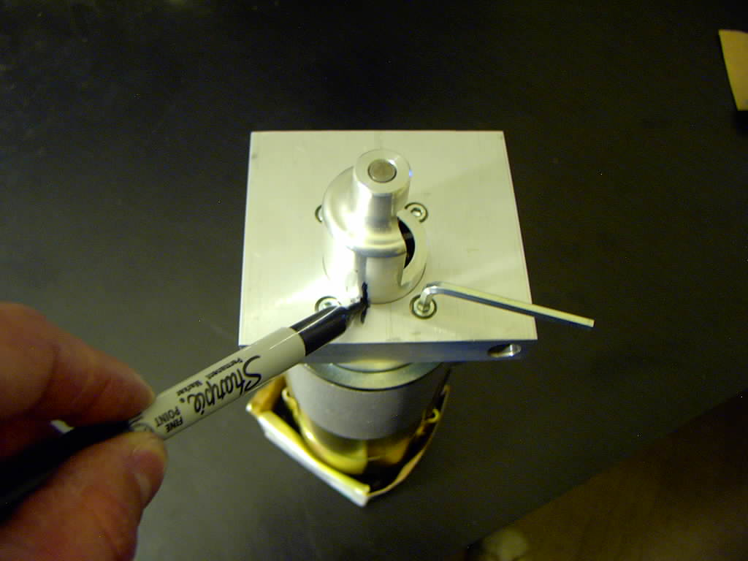
- If the starter is equipped with a pinion support cone, mark the position of the cone with respect to the nose.
- Use an allen wrench to remove the four allen head screws.
- Remove the nose (and pinion support cone if present).

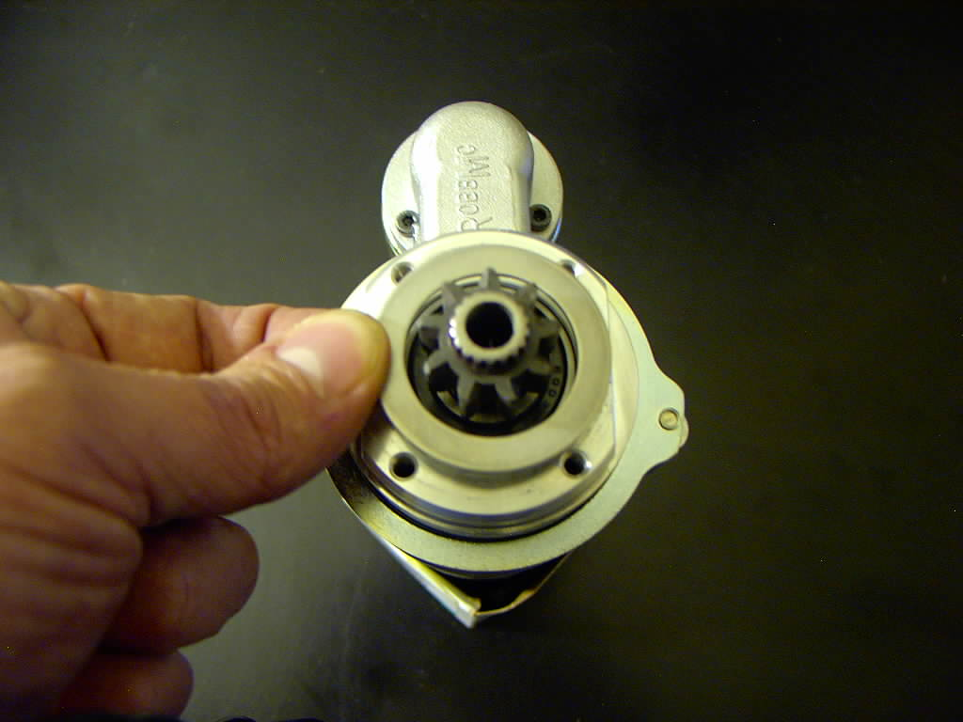
4. Install the provided 1/16” thick round shim and
center it between the four tapped holes.
(Note: A shim may already be in the starter. If so,
add the new shim to the first)
- Reinstall the nose (and pinion support cone if
used) and the four screws.

Step 4: CHECK THE BACKLASH BETWEEN THE PINION GEAR AND RING GEAR
When the pinion gear is engaged with the ring gear, there should be .015” to .030” of backlash between the gear teeth (See Figure C). If more backlash is needed for a GM block mount application, rectangular starter shims (available at any auto parts store) can be installed between the engine block and the starter nose. Refer to the Troubleshooting guide at the end of these instructions for more information about backlash.
Step 5: WIRE THE STARTER (CORRECTLY!)

BEWARE! CAUTION! ATTENTION! Because RobbMc starters use permanent magnet motors, the wiring may need to be different than your current starter. DO NOT USE A “JUMPER” WIRE OR BUSS BETWEEN THE LARGE POST AND THE SMALL POST ON THE ROBBMC SOLENOID. THIS WILL DESTROY THE STARTER. A remote solenoid or relay can still be used, but the wiring must be as shown on pages 5 and 6.

Vehicles without a remote solenoid or relay (includes most GM applications):
"B" Terminal (Post)
Connect all wires (including the battery cable) that were connected to the large terminal on the stock starter to the large “B” terminal on the RobbMc solenoid. (Note: 2 gauge or larger battery cable is recommended.)

"S" Terminal (Post)
This is the small terminal that is connected by a wire to the starter switch/key. This wire is often purple on GM vehicles. Connect it to the small terminal on the RobbMc solenoid.

"R" Terminal (Post)
Some older GM vehicles have a wire (often yellow) connected to a second small “R” terminal on the stock starter solenoid. Connect this wire to the “S” terminal on the RobbMc solenoid AFTER splicing the supplied diode into the wire. Be sure the stripe on the diode faces the direction shown in Figure D.

Vehicles with a relay for the starter activation wire (includes most Mopar applications):
On most stock Mopar applications, the RobbMc starter is wired the same way as the stock starter. Figure E is provided in case the vehicle is being rewired or the relay is being added to a non-Mopar vehicle.

Vehicles with a remote solenoid for the battery cable (includes most Ford/AMC applications): There are two methods for wiring a RobbMc starter with a Ford style remote solenoid/relay. Method 1 is recommended because it is simpler, doesn't require a diode, and extends the life of the remote solenoid.

IMPORTANT: Do not use a short “jumper” wire to connect the small post to the large post on the RobbMc solenoid. Installing a jumper wire on a permanent magnet motor can result in current feedback. This will result in starter failure.

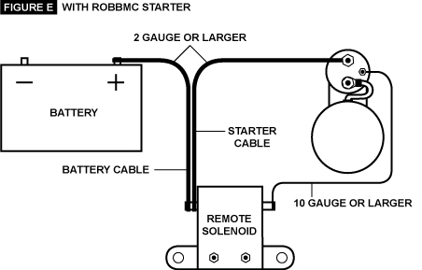
METHOD 1: (Recommended)
Note: The small wires connected to the small "I" and "S" terminals on the remote solenoid do not change and remain the same as stock.

METHOD 2:

Troubleshooting and FAQ

Why does the pinion gear remain engaged with the ring gear when the engine turns over but doesn’t start? This is typical and normal for gear reduced starters. WHEN THE ENGINE DOES NOT START, THE PINION GEAR WILL NORMALLY REMAIN ENGAGED WITH THE RING GEAR.
The end gap is more than .187”. What should I do? Please contact RobbMc Performance Products.
The pinion gear does not extend far enough to engage the entire width of the ring gear. Is this ok? As long as the pinion gear engages at least 5/16” of the ring gear, this is not a problem.
I am unable to measure the backlash. How do I know if it is ok? While it is always better to get an actual measurement of the backlash, in general, if the starter sounds ok, the backlash is probably ok. However, if the pinion gear “zings” against the ring gear but doesn’t engage the ring gear, either more backlash is needed or the ring gear teeth are damaged. Also, if the starter makes a loud “screeching” sound just as the engine starts, more backlash is probably needed. To increase the backlash on GM block mounted starter applications, add one 1/32” thick rectangular starter shim at a time between the starter nose and the engine block until the pinion engages the ring gear smoothly and disengages without “screeching”. Don’t use any more shims than necessary or you may have too much backlash. Rectangular shims are available at any auto parts store.
Some engines (including most Ford and AMC) use a starter locating plate (sandwiched between the engine and the transmission or bellhousing) to properly locate the starter the correct distance from the center of the ring gear. This ensures a proper backlash in most cases. If your engine is designed to use a locating plate, and you don’t have one, you probably have a backlash problem.
Other engines use a register diameter machined into the engine, bellhousing or transmission. For instance, most starters for Mopar applications (including the RobbMc PN 3005) register in a 1” diameter pocket machined in the bellhousing or transmission. If you are using a bellhousing on your Mopar that does not have this pocket, you probably have a backlash problem.
I have removed the starter from the engine. Can I tell by looking at the starter if it needs more backlash? Yes. Examine the root diameter of the pinion gear. (See Figure C on page 3) If there are witness marks where the teeth of the ring gear have made contact with the root diameter of the pinion gear, more backlash is needed (unless the witness marks were made before shims were added). If you are unsure, use a black permanent marker on the root diameter of the pinion gear, install the starter, crank the engine a couple times, remove the starter and check the root diameter again for witness marks.
How do I know if I have a good electrical ground for the starter? The starter grounds through the mounting surface. If the engine block, starter, starter locating plate or bellhousing is painted or dirty where the starter mounts, the starter may not get a good ground. Make sure the mounting surface is clean and paint free.
When I turn the key to the start position, the starter does nothing or I just hear a “click” sound. What is wrong?: Check all the connections and grounds. Make sure the starter is wired properly. Make sure the battery is charged. Use a volt meter or test light to make sure you are getting electricity to the small terminal/post on the starter solenoid when the key is in the “start” position. If your vehicle uses a remote solenoid or relay, make sure it is working properly.
Vehicles which do not use a remote solenoid or relay (including most GM products) often suffer from insufficient electrical current delivery to the small terminal/post on the solenoid, especially older cars where the electrical contacts and switches are old, worn and corroded. If there is insufficient power transmitted, the solenoid will do nothing or just "click" rather than activating the starter motor. If this happens, test the starter using a remote starter switch (see photo below). This connects the positive battery post directly to the small terminal/post on the starter, bypassing all the wiring in the car. If the starter works with the remote starter switch, install a Mopar or Ford style relay (See Figure E and Figure F of these instructions).
