

RobbMc Performance Products LLC
2960 Cameron Court
Carson City, NV 89706
www.robbmcperformance.com
robb@robbmcperformance.com
775-885-7411

Dual Mode Fuel Pressure Regulators PN 1046, 1050 and 1051

Introduction: The RobbMc Dual Mode fuel pressure regulator can be used as a dead-head (non-return) regulator or as a bypass (return) regulator depending on which plunger is used. Regulator 1046 is shipped from the factory with both the dead-head plunger (installed) and the bypass plunger. Regulator 1050 is shipped with the dead-head plunger only. Regulator 1051 is shipped with the bypass plunger only.

Applications: Carburetors using gasoline or alcohol fuels.

Maximum Recommended Pump Volume: 300 gph free flow

Pump Pressure: For best performance, the pump should be able to provide a pressure at least 3 psi higher than the set pressure of the regulator. In the dead-head mode, do not use a pump that will produce over 30 psi.

Adjustment Range: 3 to 10 psi

Inlet Port: 1/2 NPT in dead-head mode; 3/8 NPT in bypass mode

Outlet Ports: Three 3/8 NPT in dead-head mode; Two 3/8 NPT in bypass mode

Gauge Port: 1/8 NPT Bypass Port (Bypass Mode Only): ½ NPT

Recommended Fuel: Gasoline or alcohol (use supplied Nitrile o-ring(s) when running over 50% alcohol)

Recommended Inlet Line Size: ½” (or -8AN)

Recommended Outlet Line Size: One 3/8” (or -6AN) line to each carburetor bowl

Recommended Return Line Size (Bypass Mode Only): See Bypass Mode section of instructions

Plunger O-ring: The dead-head plunger is supplied from the factory with Viton o-ring installed. Viton is preferred when running gasoline. When running more than 50% alcohol, replace the Viton o-ring with the Nitrile (Buna-N) o-ring (which is supplied separately).

Boost Reference: The regulator includes a fitting which accepts a 3/16” rubber hose for boost referencing/indexing on blow through applications. Applying boost pressure to this fitting will increase fuel pressure 1 psi for every 1 psi of boost. Leave the fitting open to atmosphere if not used for boost indexing.

Dead-Head (non-return) Mode
(mechanical or electric fuel pumps)

The 1046 and 1050 regulators are shipped from the factory in the dead-head mode. No return line is required for the dead-head mode.

When using a mechanical fuel pump, the regulator MUST be in the dead-head mode.

When using an electric fuel pump, the regulator can be in either the dead-head or bypass mode, however the bypass mode is usually preferred. (See Bypass Mode section of instructions)

Pump Requirements: For best results, the fuel pump should be able to produce a pressure at least 3 psi higher than the set pressure of the regulator. For example, if the regulator is to be set at 7 psi, the pump should be able to produce at least 10 psi. Do not use a pump that will produce over 30 psi. The volume produced by the pump must be sufficient for the horsepower of the engine (ask the pump manufacturer for recommendations).

Fuel Line Connections: When in the dead-head mode, the inlet line from the pump must be connected to the bottom ½ NPT port. The 3/8 NPT ports on the side of the regulator are outlets to the carb(s). The small 1/8 NPT port is used for a gauge and/or a RobbMc vapor return fitting PN 1010.

Dead-Head (non-return) Mode
(continued)

Vapor Return Fitting: When using a dead-head regulator, vapor lock or pressure creep can be a problem, especially on street cars in hot weather. If the car is equipped with a ¼” vapor return line (many cars came from the factory with a small vapor return line) the optional RobbMc Vapor Return Fitting PN 1010 can be used to circulate a small amount of fuel back to the tank. (The fitting has a very small I.D. to allow only a small amount of fuel to circulate). While this is not the same as using a bypass style regulator (where all of the unused fuel is returned to the tank), it does help keep the fuel slightly cooler. Install the vapor return fitting in the 1/8 NPT port in the regulator and connect the return line to the fitting. (If the 1/8 NPT port is also used for a gauge, a tee fitting will be required).

Regulator Mounting: The regulator should be mounted within three feet of the carburetor. In general, closer is better, however mounting the regulator directly to the engine is not highly recommended due to the vibrations and high temperatures. As the regulator heats up the fuel pressure will drop slightly (usually about ½ psi). If the regulator is mounted directly to the engine, the extra heat may lower the pressure 1 psi or more.

In many cases the regulator can be mounted by suspending it in the fuel line so no mounting bracket is required. If a mounting bracket is desired (for mounting the regulator on the inner fender for example) the optional RobbMc Mounting Bracket PN 1049 can be used. This bracket can be attached to the regulator in eight different ways providing a multitude of mounting options.

Fuel Pressure Gauges: Mounting a fuel pressure gauge on or near the engine is not recommended because pressure gauges tend to read lower as the temperature of the gauge increases. Try to mount the gauge remotely using a small fuel line, or use an electric pressure gauge. If you must mount a pressure gauge on/near the engine, DO NOT use a liquid filled gauge. Liquid filled gauges are notorious for providing false readings when the gauge is hot.

Regulator Pressure Setting Adjustment: The regulator will adjust from about 3 psi to 10 psi. Loosen the jam nut and turn the set screw clockwise to increase pressure. Do not try to adjust the pressure higher than 10 psi as this may damage the regulator. Tighten the jam nut after adjusting the pressure to prevent the set screw from rotating.
Note: The fuel pressure on a dead-head regulator cannot be adjusted unless the engine is running.

NPT Fittings: Use Teflon sealant on all tapered NPT threads. This not only seals the threads but also helps prevent galling of the threads, especially when aluminum fittings are used.

TROUBLESHOOTING: If the regulator does not seem to function properly, check the following;
~Make sure the fuel pressure gauge is accurate (do not mount a liquid filled gauge in the engine compartment).
~Make sure the fuel pump is providing enough fuel (it must provide a pressure at least 3 psi more than the set pressure of the regulator, and enough volume for the power of the engine).
~Make sure the inlet line is connected to the bottom (1/2 NPT) port on the regulator.
~Check the o-ring on the regulator plunger. If it is damaged or missing, replace it with a #011 o-ring.
~Check the regulator diaphragm. It should be dry on the top surface. If leaking, check the condition of the diaphragm and the sealing washer.

Bypass (return) Mode
(Electric fuel pumps only)
The 1051 regulator is shipped from the factory in the bypass mode. To change the 1046 or 1050 regulator to the bypass mode the plunger must be changed. (See instructions on following pages).

Do NOT use mechanical pumps with the regulator in the bypass mode. The pressure will bounce severely.

When using an electric fuel pump, the regulator can be in either the dead-head or bypass mode, however the bypass mode is usually preferred. Bypass regulators make electric pumps quieter and more efficient. Bypass regulators eliminate vapor lock, pressure creep and make electric pumps live longer. When used with a sufficiently large return line, bypass regulators produce less pressure drop at full throttle.

Pump Requirements: For best results, the fuel pump should be able to produce a pressure at least 3 psi higher than the set pressure of the regulator. For example, if the regulator is to be set at 7 psi, the pump should be able to produce at least 10 psi. There is no upper limit on pump pressure with a bypass regulator. The volume produced by the pump must be sufficient for the horsepower of the engine (ask the pump manufacturer for recommendations).

Fuel Line Connections: The inlet line from the pump may be connected to any one of the three 3/8 NPT ports on the side of the regulator. The other two 3/8 NPT ports on the side of the regulator are then outlets to the carb(s). The small 1/8 NPT port can be used as a gauge port. The ½ NPT port on the bottom of the regulator must be connected to the return line.

Bypass (return) Mode
(continued)

Return Line: When using the regulator in the bypass mode, a return fuel line is required from the bottom of the regulator back to the fuel tank/cell. For proper regulator function, there must be very little resistance to flow in the return line. Avoid 90 degree fittings. Connect the return line near the top of the fuel tank/cell. Use the following as a guideline to determine the minimum return line size:

Fuel pumps up to 70 gph: 5/16” or -4AN
Fuel pumps up to 100 gph: 3/8” or -6AN
Fuel pumps up to 180 gph: ½” or -8AN
Fuel pumps up to 300 gph: 5/8” or -10 AN

Return Line Backpressure: Even when the recommended return line size is used, it is important to check the backpressure in the return line. Once the pump and regulator are installed and all the lines are connected, check the backpressure in this manner:

~Remove the jam nut and pressure adjustment set screw.
~With the engine off (not running) turn on the electric fuel pump. Let the pump run until the lines are full of fuel.
~With the pump still running, check the fuel pressure gauge. It should read no more than 3 psi (less is better).
~If the gauge reads more than 3 psi, the restriction in the return line is too high.
~If the restriction is too high, reduce the restriction with larger lines, fewer sharp bends, etc.

Regulator Mounting: The regulator should be mounted within three feet of the carburetor. In general, closer is better, however mounting the regulator directly to the engine is not highly recommended due to the vibrations and high temperatures. As the regulator heats up the fuel pressure will drop slightly (usually about ½ psi). If the regulator is mounted directly to the engine, the extra heat may lower the pressure 1 psi or more.

In many cases the regulator can be mounted by suspending it in the fuel line so no mounting bracket is required. If a mounting bracket is desired (for mounting the regulator on the inner fender for example) the optional RobbMc Mounting Bracket PN 1049 can be used. This bracket can be attached to the regulator in eight different ways providing a multitude of mounting options.

Fuel Pressure Gauges: Mounting a fuel pressure gauge on or near the engine is not recommended because pressure gauges tend to read lower as the temperature of the gauge increases. Try to mount the gauge remotely using a small fuel line, or use an electric pressure gauge. If you must mount a pressure gauge on/near the engine, DO NOT use a liquid filled gauge. Liquid filled gauges are notorious for providing false readings when the gauge is hot.

Regulator Pressure Setting Adjustment: The regulator will adjust from about 3 psi to 10 psi. Loosen the jam nut and turn the set screw clockwise to increase pressure. Do not try to adjust the pressure higher than 10 psi as this may damage the regulator. Tighten the jam nut after adjusting the pressure to prevent the set screw from rotating.

NPT Fittings: Use Teflon sealant on all tapered NPT threads. This not only seals the threads but also helps prevent galling of the threads, especially when aluminum fittings are used.

Bypass (return) Mode
(continued)

TROUBLESHOOTING: If the regulator does not seem to function properly, check the following;
~Make sure the fuel pressure gauge is accurate (do not mount a liquid filled gauge in the engine compartment).
~Make sure the fuel pump is providing enough fuel (it must be able to provide a pressure at least 3 psi more than the set pressure of the regulator, and enough volume for the power of the engine).
~Make sure the return line is connected to the bottom (1/2 NPT) port on the regulator.
~Check the regulator diaphragm. It should be dry on the top surface. If leaking, check the condition of the diaphragm and the sealing washer.
~With the adjustment screw backed all the way out, the pressure gauge should read no more than 3psi. If the pressure is higher than 3 psi, decrease the flow restriction in the return line.
~If the fuel pressure drops too much during full throttle, check pump flow and return line restriction.

CHANGING FROM DEAD-HEAD TO BYPASS MODE

Step 1: Loosen the jam nut and remove the pressure adjustment set screw:
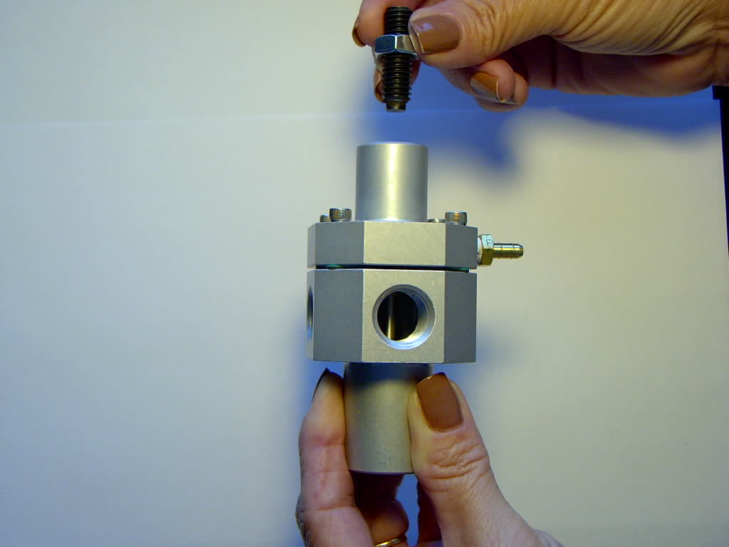

Step 2: Using an allen wrench, remove the four screws holding the cap to the housing:
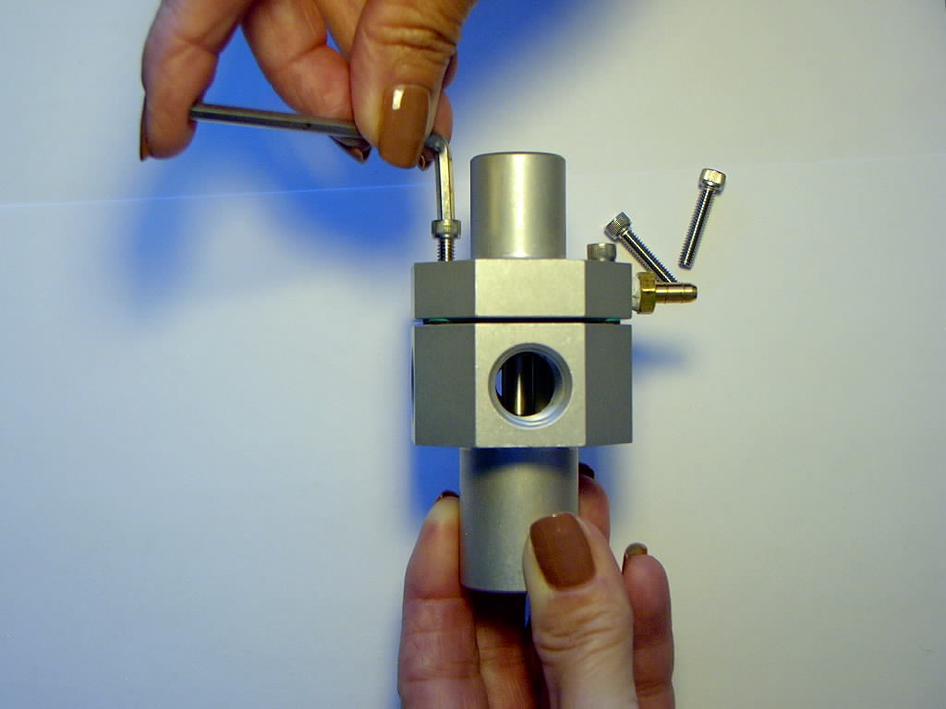

Step 3: Remove the cap, thrust washer and spring:
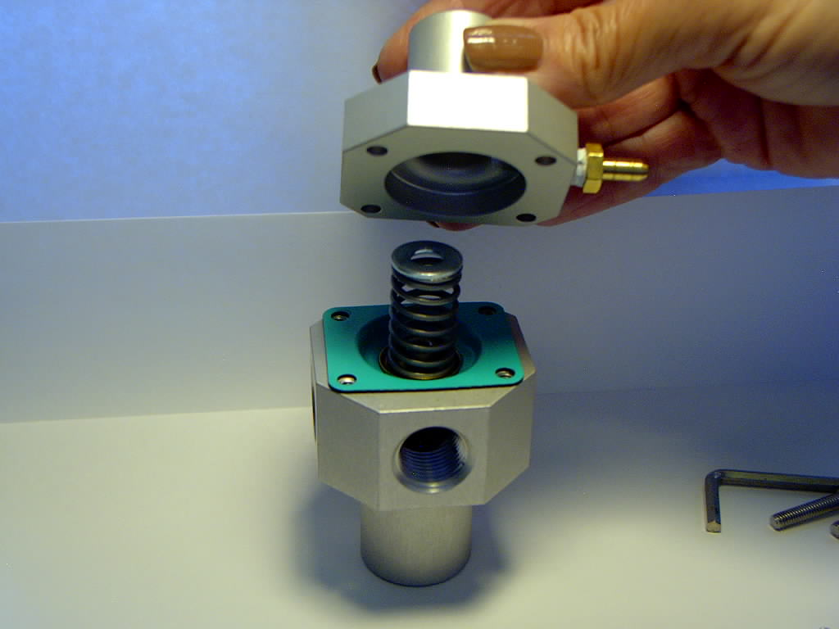

Step 4: Use a 7/16” socket driver and an allen wrench to disconnect the dead-head plunger from the diaphragm:
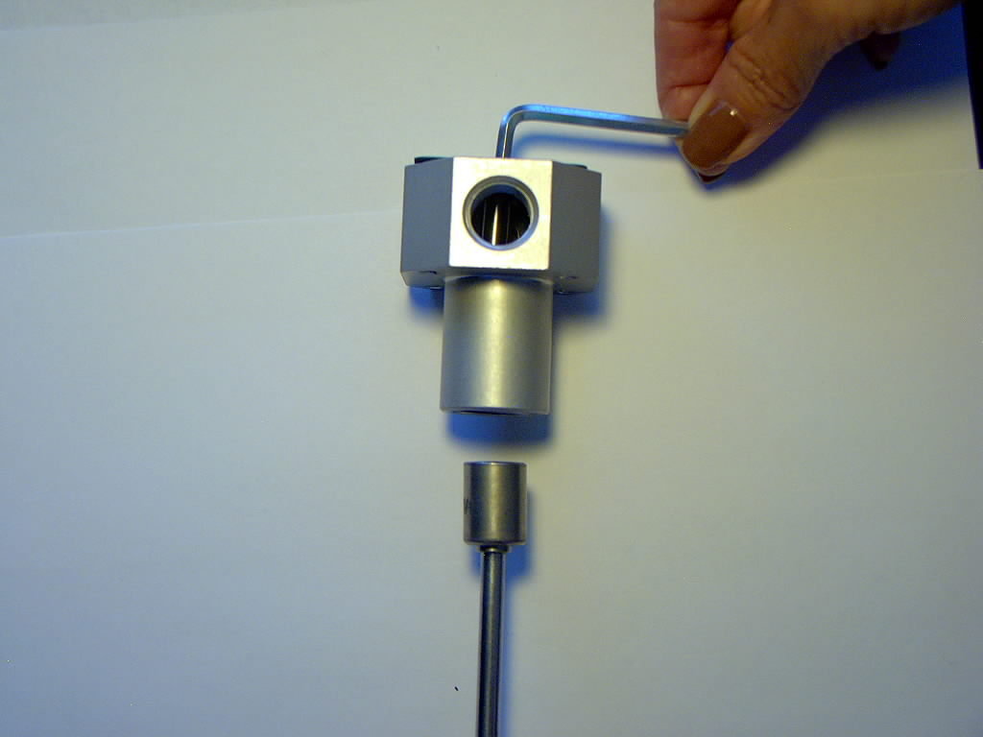

Step 5: Pull the diaphragm assembly and dead-head plunger from the housing:
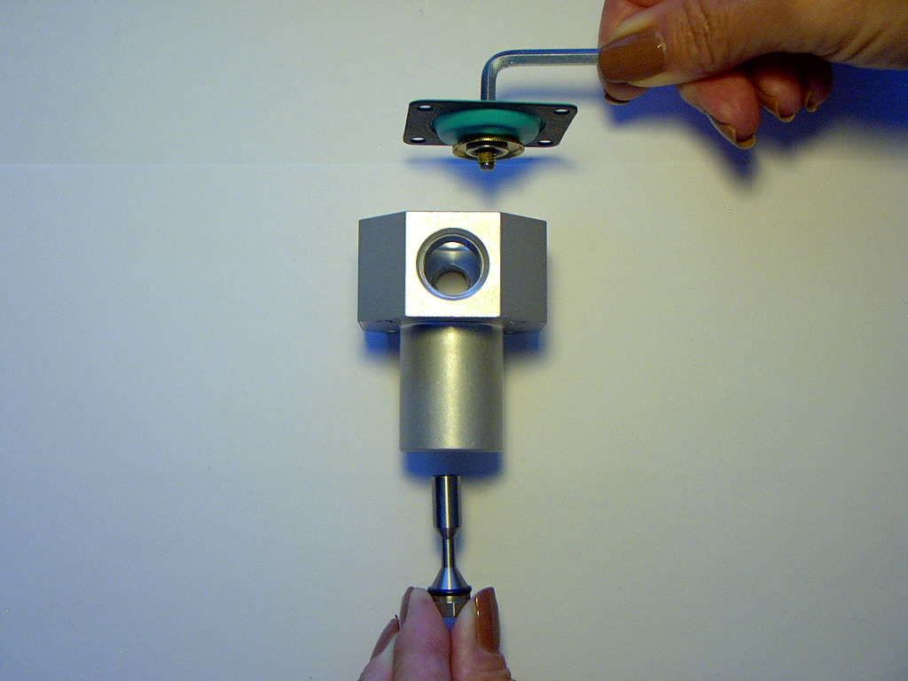

Step 6: Screw the bypass plunger onto the diaphragm assembly and tighten (make sure the sealing washer stays in place):
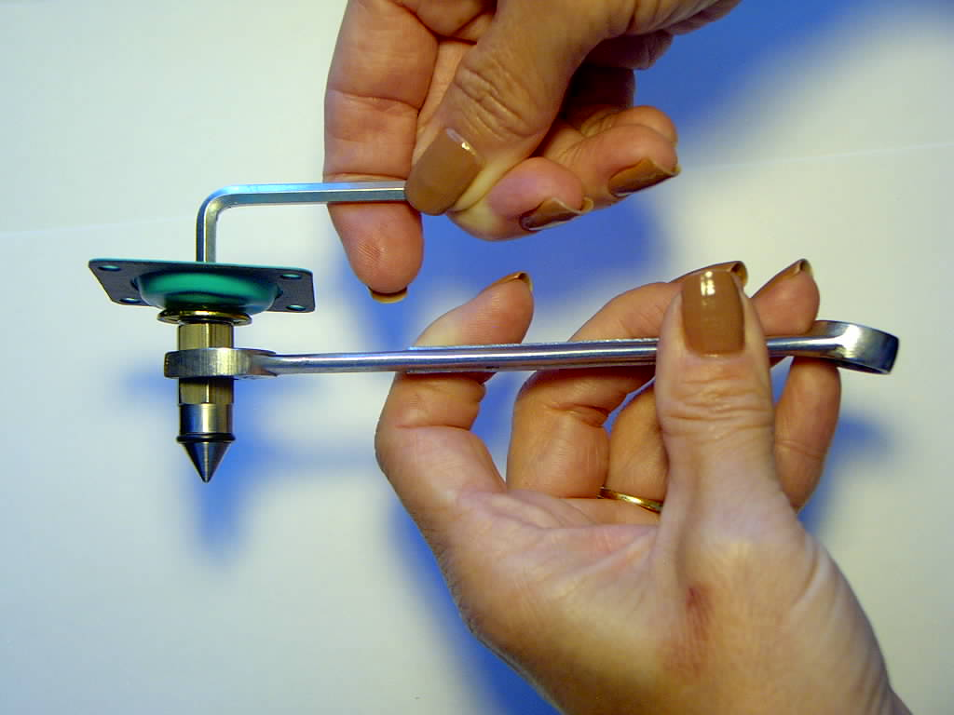

Step 7: Insert the diaphragm assembly and attached bypass plunger into the top of the housing:
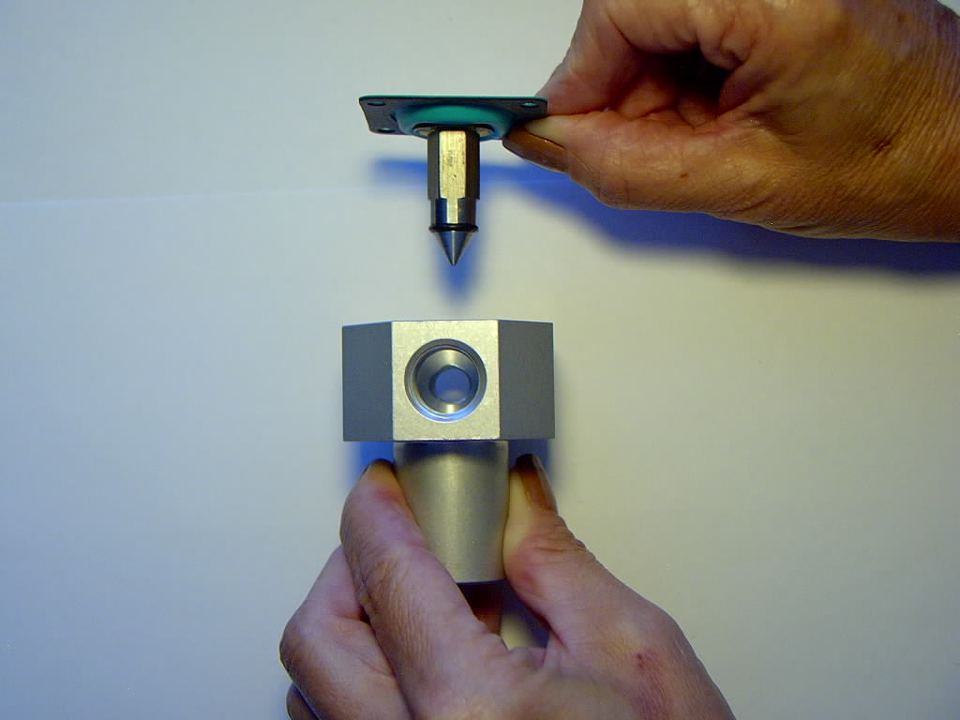

Step 8: Set the spring (with the thrust washer on top) on the diaphragm assembly and install the cap:

Install and tighten the cap screws with an allen wrench:

Install the pressure adjustment set screw and jam nut:

CHANGING FROM BYPASS TO DEAD-HEAD MODE

Converting the regulator from bypass mode to dead-head mode is simply the reverse of that shown above in the photos.

